28.AIM:- ***To draw the UML diagrams for Airline reservation system using umbrello.***

CLASS DIAGRAM:

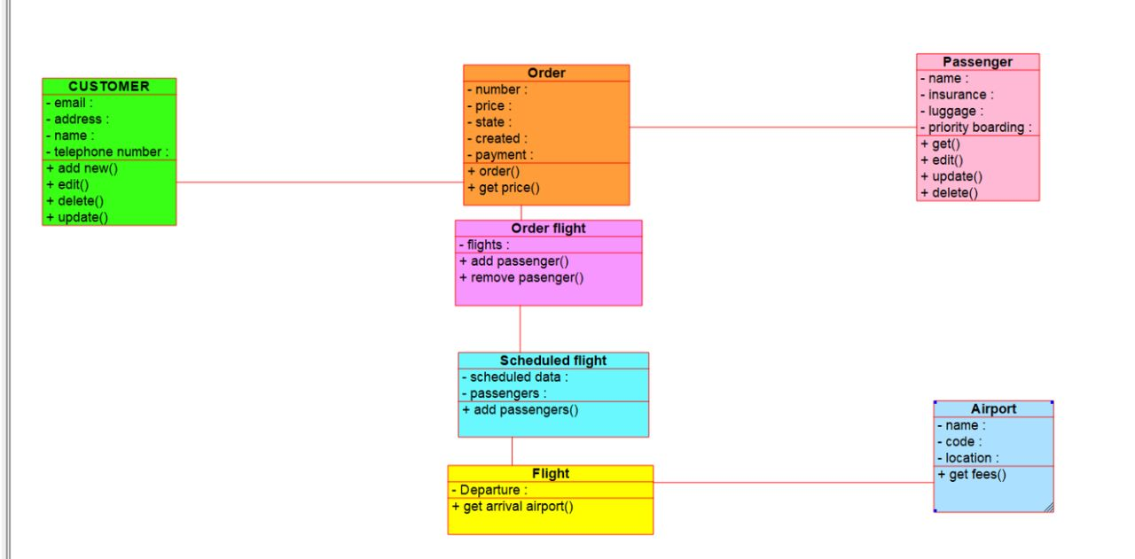

ACTIVITY DIAGRAM:

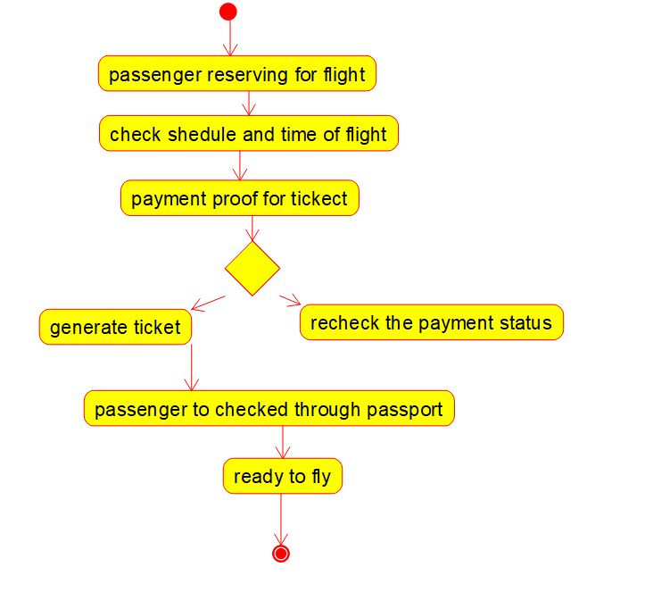

USE CASE DIAGRAM:

